**Project Plan and User Requirements**

**Members**

* Eldin Delic Hodzic (X00153243) (EDH)
* Dylan Byrne-Carr (X00155165) (DBC)
* Sean Brownlee (XXXXXXXXX) (SB)

**Goals of the project**

Our plan to build a successful project by making the website user friendly as possible, providing the users with a unique environment such as implementing more unique features that the user will find comfortable. -EDH

We plan to include several security measures so that the user can feel safe while shopping and making payments, and a detailed database filtering system for the user to easily sort through products. -DBC

Making the website aesthetically pleasing so that the user is comfortable shopping, updating information and more as the user will be the one using the website. -EDH

**Feasibility of project**

Our project consists of many basic functionalities such as sign in/sign out, making accounts, updating carts and payment, while also adding additional functionalities such as more security (2FA), and user email updates. -EDH

One potential issue with the development of the program is that many features rely on others to work in order for them to work. In order for two factor authentication to be implemented we need to first get email up and running. -DBC

The design of the website is not our biggest concern at first however we are planning on making it as user friendly as possible, using the least amount of clicks we can to bring our customers through the order process. -DBC

**Use Case Diagram and Descriptions** - ( descriptions EDH 50% DBC50%), diagram - DBC

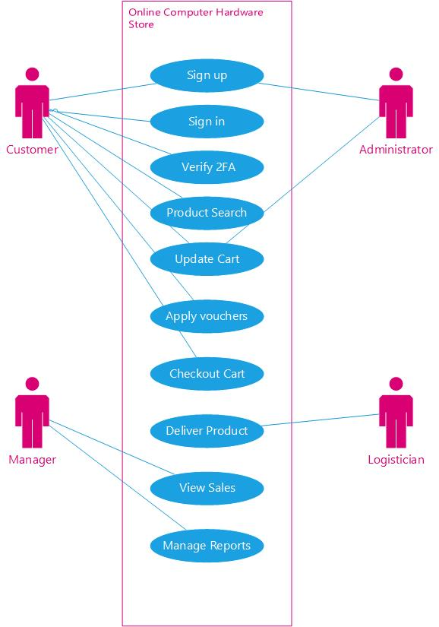

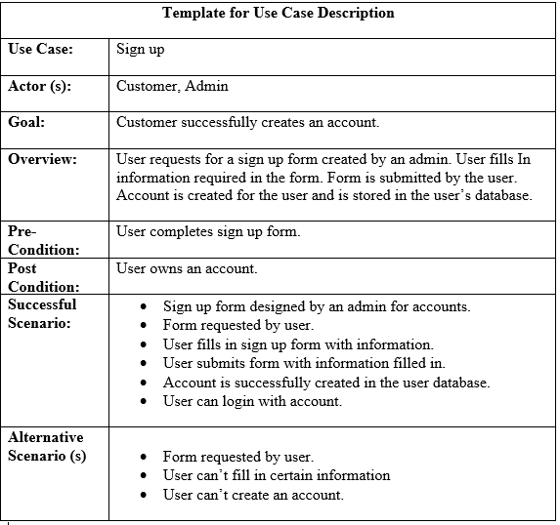

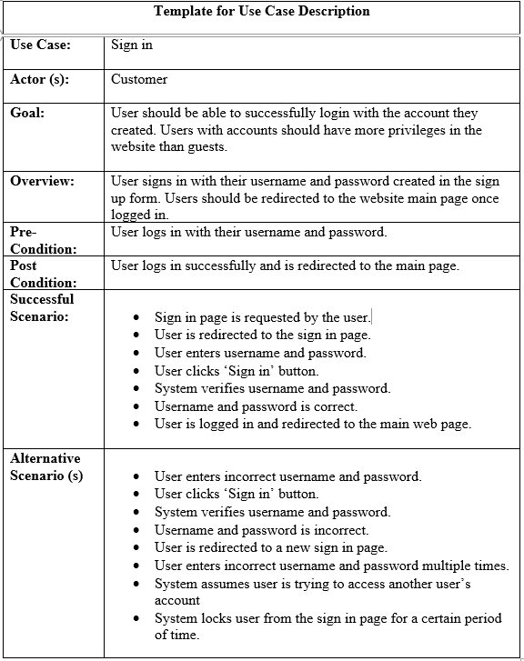

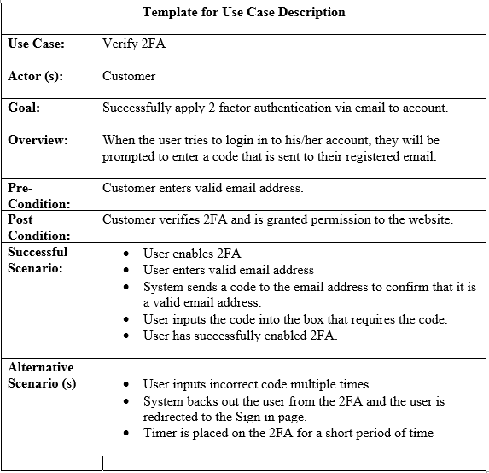

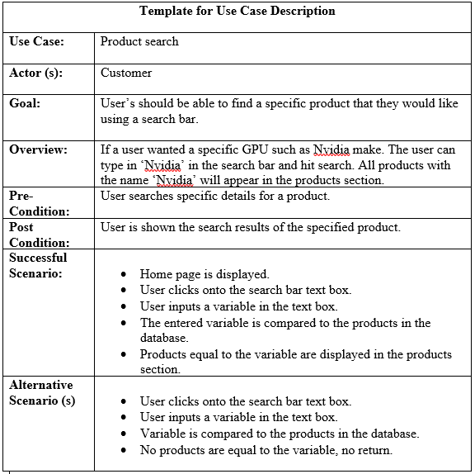

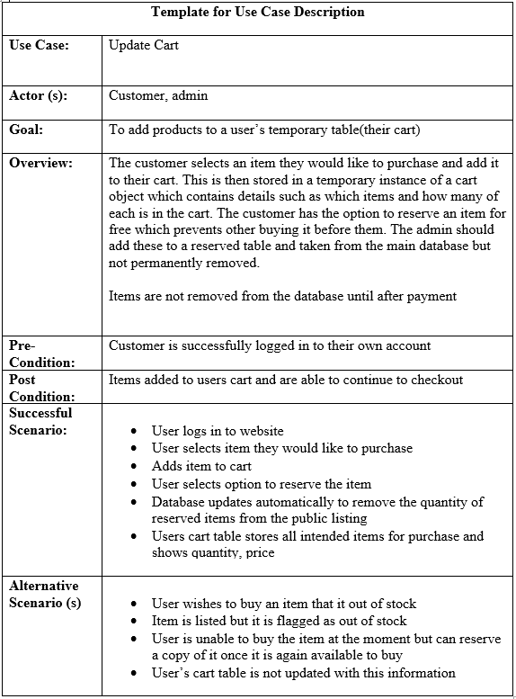

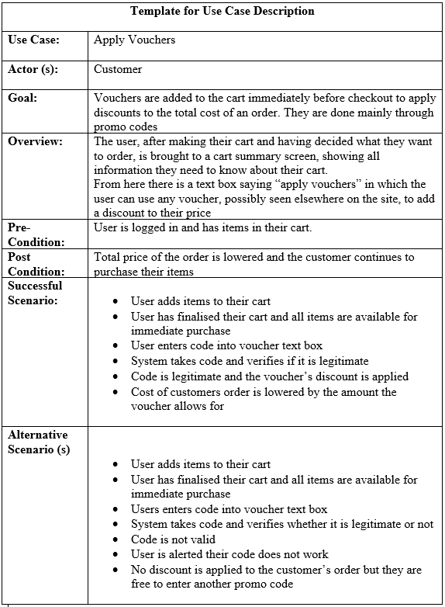

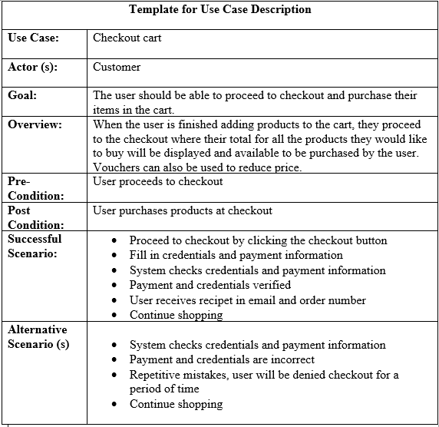

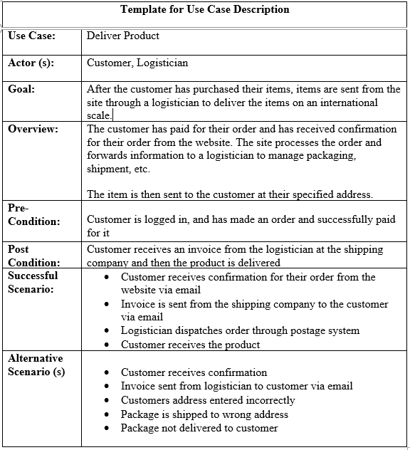

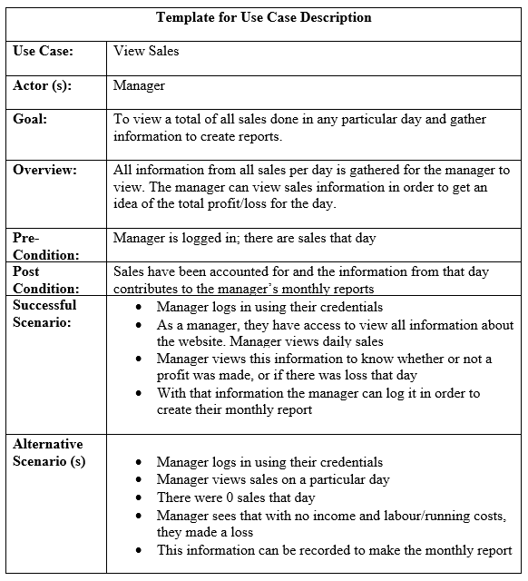

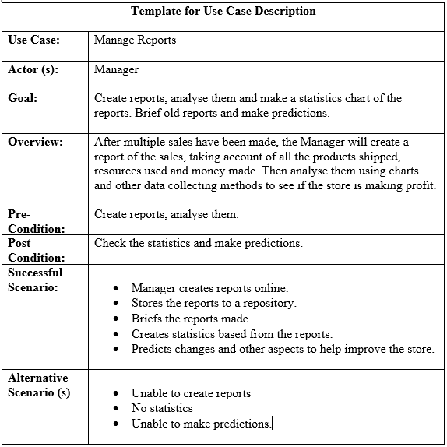

**Priorities**

Our priorities for this project will be based around improving the experience for the user. The following are our main priorities: - EDH

* Detailed and organised database - Make the database simple and clean, by keeping data under the same category and not mixing them up. -DBC
* Constructive administration system - Group of admins who will monitor the database and the website. Make modifications or add new data to the website and database. -DBC
* Cart features and payment - Allow the user to remove or add products to the cart easily without complexity. Payment will be used with Stripe to make it simple. -EDH
* Email communication - Notifications about our website to the Users email. Users will receive important notices as well as deals and offers. -EDH
* Two factor authentication using randomised passwords sent via email - Similar to email communication, the user can enable extra security by linking their email with their account. -EDH
* User friendly functionality - As the user shops for products, we want the website to be flexible and easy to use in a user friendly environment. -EDH

**Iteration goals**

**Iteration 1:**

For the first iteration, we will begin coding the websites basic functions, as a starting point. Functions such as sign in/sign out, create account, products and cart are the basics of our website. -EDH

We will have a working database with only a skeleton of products but more will be added later as they are not required just yet. -DBC

We plan on having a well made administrator account with access to manipulate all aspects of the website, and a manager who can flag items as out of stock as well as view reports and sales. The customer will just be able to manage a cart pay for an order, and view their order history -DBC

The website will still be under progress but still be a functioning website for the user to browse. The user will be able to create an account, sign in, sign out and add products to the cart. - EDH

**Iteration 2:**

Once we have the basic functions done, we will then move onto making the website more advanced, with new features as well as some unique features. Adding functions like payment, email notifications, subscriptions, vouchers and other assets that the user might find helpful. -EDH

Our payment will be coded using Stripe, a useful 3rd party payment which can be used in the Django framework. Email notifications when a user signs up for a subscription, when they make an account or purchase. For users who create accounts, they will be given a one time voucher to start off with.

-EDH

Email communication is a must and will be one of the first things to be implemented on the website. - DBC

**Iteration 3:**

The final iteration will be based on the overall design of the website and try to add in any final functions. We will also showcase the prototype of our website and run tests before finalizing it. -EDH

The design part of it will be used with HTML, CSS, JavaScript, Bootstrap and more. Using these languages to make the design as unique as possible. -EDH

**Noun Identification** - EDH

|  |  |  |  |  |
| --- | --- | --- | --- | --- |
| No. | Extracted Text | Type | Classes | Desc. |
| 1 | User | Roles | User | Another word for customer |
| 2 | Form | Irrelevant |  | Sign in/out form, 2FA form |
| 3 | Admin | Roles | Admin | Administrator, manages database and website |
| 4 | Information | Attribute | Attribute of User, Cart, Payment | Credentials, details |
| 5 | Account | Attribute | Attribute of User | A special role that can be made by the user |
| 6 | Database | OOS |  | Stores data, information and other resources |
| 7 | Privileges | Attribute | Attribute of User, Manager and Admin | Special action given to specific roles |
| 8 | Website | OOS |  | Online Hardware Store |
| 9 | Guests | OOS |  | Users who don’t own accounts |
| 10 | Username | Attribute | Attribute of User, Manager and Admin | Made by the user. Required to make an account, sign in |
| 11 | Password | Attribute | Attribute of User, Manager and Admin | Made by the user. Required to make an account, sign in |
| 12 | Page | Irrelevant |  | Home, sign in/out, cart, purchase pages. |
| 13 | System | OOS |  | Website layout, attributes and associations |
| 14 | Products | Roles | Product | Items that are up for sale in the store, purchased by user. |
| 15 | Search bar | Attribute |  | Unique feature to assist users in searching for specific products |
| 16 | GPU | OOS |  | Type of product |
| 17 | NVIDIA | OOS |  | Name of type of product |
| 18 | Text box | Irrelevant |  | Feature that allows users to input parameters |
| 19 | Return | Vague |  | Redirect |

|  |  |  |  |  |
| --- | --- | --- | --- | --- |
| 20 | Table | OOS |  | Holds the products with information about the products |
| 21 | Cart | Roles | Cart | Unique feature that allows users to save wanted products and to purchase them |
| 22 | Instance | Vague |  |  |
| 23 | Payment | Attribute | Payment | Allows users to purchase their products using payment information |
| 24 | Listing | Duplicate |  |  |
| 25 | Quantity | Attribute | Attribute of Product | A small feature that allows the user to buy multiple of the same item |
| 26 | Price | Attribute | Attribute of Product | Price of the products |
| 27 | Stock | Attribute | Attribute of Product | How many products are in store |
| 28 | Reservation | Attribute | Attribute of Product | Allows users to reserve products |
| 29 | Voucher | Roles | Voucher | A discount on products |
| 30 | Checkout | Attribute | Attribute of Cart | Page where the user proceeds to the payment process |
| 31 | Receipt | Attribute | Attribute of Payment | After a user makes a purchase, they will receive information based on the product and their purchase |
| 32 | Mistakes | Irrelevant |  |  |
| 33 | Logisitican | OOS |  | A role that organises the products delivery |
| 34 | Confirmation | Attribute | Attribute of Payment | User confirmation on buying products |
| 35 | Packaging | Duplicate |  | When an order is completed by the user, it is packaged for shipment. |
| 36 | Shipment | Duplicate of Delivery |  | Beginning of the delivery of the product |
| 37 | Invoice | Attribute | Attribute of Payment | A detailed report given to users containing information about their details, purchase and product |
| 38 | Postage | Duplicate |  | After shipment, it is sent to the post. |
| 39 | Delivery | Attribute | Attribute of Payment | From the post, it is delivered to the users address. |

|  |  |  |  |  |
| --- | --- | --- | --- | --- |
| 40 | 2FA | Attribute | Attribute of User | A special security feature that gives users more security by sending a code to their verified email when signing in. |
| 41 | Email | Attribute | Attribute of User | Created by the user, used for 2FA and order of products. |
| 42 | Code | Attribute |  | Generated by the 2FA system. |
| 43 | Permission | Duplicate |  | Similar to privileges, given to specific roles. |
| 45 | Input | Association |  | Parameters given by the user. |
| 46 | Time | General |  |  |
| 47 | View | Association |  | Users can view their order history and their accounts, Managers can view sales and Admins can view Database. |
| 48 | Sales | Roles | Sale | Controlled by the manager, creates reports and briefs based on the sales. |
| 49 | Manager | Roles | Manager | Special role that organises the sales and reports generated. |
| 50 | Days | Irrelevant |  |  |
| 51 | Reports | Attribute | Attribute of Sales | Created and briefed by the manager. |
| 52 | Order | Roles | Order | Created by the user when successfully purchasing a product. |
| 53 | Idea | Irrelevant |  |  |
| 54 | Profit | Attribute | Attribute of Sales | The stores gains in terms of money |
| 55 | Loss | Attribute | Attribute of Sales | The stores loss in terms of money |
| 56 | Logs | Attribute | Attribute of Admin | All actions that were executed by roles that can be checked by an Admin |
| 57 | Access | Duplicate |  | Similar to permissions, certain roles have access to certain things. E.g. Admin can access the database. |
| 58 | Income | Duplicate |  | The money generated from the store. |
| 59 | Statistics | Vague |  | A detailed page, usually with a chart that shows all information about the store. |

|  |  |  |  |  |
| --- | --- | --- | --- | --- |
| 60 | Chart | Duplicate |  | Pie, bar, line chart |
| 61 | Brief | Duplicate |  | Made by the manager from the reports. |
| 62 | Predictions | Attribute | Attribute of Sales | The manager makes predictions based on analyzing the reports and the brief. |
| 63 | Category | OOS |  | A list of all products that were sold, how much were sold and how much was made |
| 64 | Money | Duplicate |  |  |
| 65 | Resources | General |  | Products, money, data that is stored in the database. |
| 66 | Data | General |  | Stores in the database. |
| 67 | Methods | Attribute |  |  |
| 68 | Online | Attribute |  | Allows shopping over the internet. |
| 69 | Repository | Attribute |  | Similar to a directory, it’s used to store data. |
| 70 | Aspects | Vague |  | Other features or functions of the website, and database |
| 71 | Changes | Irrelevant |  | Modifications or data that was altered. |

**Class diagram(s)** -DBC

